**ES202 Course Notes Supplement**

**Introduction to SIMULINK**

Before starting Simulink, you must start MATLAB. With MATLAB running there are several ways to start Simulink including:

* Clicking on the *Simulink* icon  in the MATLAB toolbar.
* Entering the command **simulink** at the MATLAB prompt.
* Opening an existing Simulink model by clicking on the *open file* icon in the MATLAB toolbar.
* Typing the name of an existing Simulink model at the MATLAB command prompt

The first two methods will open the Simulink Library Browser shown below.

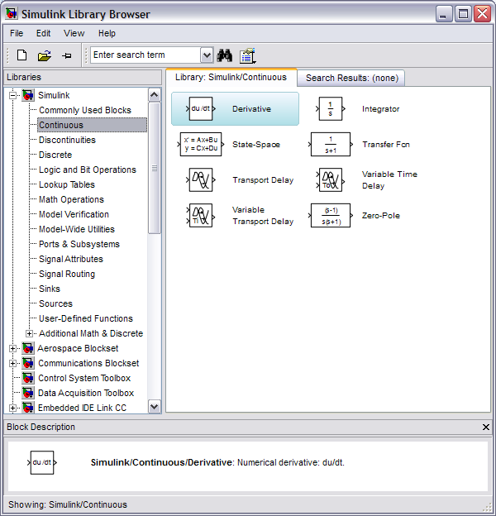

Creating a New Model Using the Simulink Library Browser

Simulink uses *model files,* which are visual representations of systems (typically differential equations and mathematical functions). You create a simulation model by:

1. Opening a new model window by clicking on the blank page ‘Create a new model’ icon on the Simulink Library Browser menu bar, or opening an existing model from the *File Open* menu bar.
2. Locating and dragging selected blocks from the Browser to your model window
3. Connecting chosen blocks to form a system
4. Setting various block and system parameters
5. Saving your model by clicking on the *save file* icon located in the model’s menu bar

**Adding a block From the Simulink library**

The Simulink Library Browser provides a tree-structured library of simulation blocks. To navigate the Simulink Library Browser, click on the ‘expand’ (+) or ‘collapse’ (-) blocks in the left-hand frame, or click on any entry. The right-hand frame will change to reflect the contents of the given library or toolbox. White objects in the right-hand frame are Simulink blocks, while the gray- or gold-colored objects are additional sub-libraries that can be expanded by clicking on the ‘+’ in the lower left-hand corner of the block. In the previous example Simulink Library Browser window, the *Simulink* toolbox and the *Continuous* sub-library have been expanded and a simple derivative selected. Notice that the frame at the bottom of the Simulink Library Browser window describes the selected block.

To copy a block from the Simulink Library Browser window:

1. Point your mouse to desired block
2. Hold down the left mouse button and drag the block to your simulation model window
3. Release the mouse button

Modifying Block Parameters

Every block that you will use in Simulink has a set of parameters that must be set appropriately for your simulation to function. To bring up a dialog box in which you can modify these parameters, double-click on the block (in the model window, not the Simulink Library Browser). You can also right-click on any block in a model to bring up other options.

**Numerical Integration in Simulink**

If you drag the *integrator* block from the *Continuous* sub-library of the Simulink Toolbox, you will have an object that looks like the block to the right. On the left side of the block is an input “nub” for the integrand. The output “nub” on the right side of the block outputs the integral.

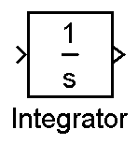

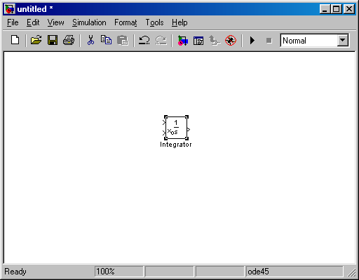

You can set initial conditions for integrators in two ways. In the ‘Integrator Parameters’ for the integrator, the initial conditions can be given a source of ‘Internal’ or ‘External.’ ‘Internal’ initial conditions are set in the ‘Block Parameters.’ ‘External’ initial conditions are set by passing a signal into the integrator, which will change to include another input as soon as ‘External’ is selected, as seen at right.

To set the initial condition externally, you may use a *constant* block from the ‘Sources’ sub-library. This will allow you to see the initial condition value when you run and print the Simulink model.

**Creating Input Signals**

The Simulink Library Browser*Simulink / Sources* library contains various signal generators. The simplest is a *step* function which looks like the block to the right:

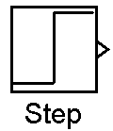

***IMPORTANT:*** By default, the output amplitude is 1.0 and the step occurs at . To change the step time to , double click on the step block and change the step time field to 0. You will need to make this change every time you use the Simulink step function.



The integral of the step input is a ramp input. In Simulink, you can drag a *ramp* block from *Simulink / Sources* to obtain:

Note that you could also combine *step* and *integrator* blocks to achieve the same result:

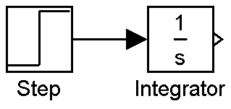

**NOTE:** You connect blocks by depressing the left mouse button on an output “nub” and dragging the mouse to the corresponding input “nub”.

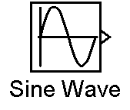

Another useful input signal is a sine wave:

**Performing Basic Math Operations**

The Simulink Library Browser*Simulink / Math Operations* library contains commonly used math functions.

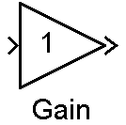

To multiply a signal by a constant, use the *gain* block to the right:

By default, the gain is one (1). To change the gain, double click on the gain block and change the ‘gain’ field in the Block Parameters window.

To add two signals, use a *sum* block. By double clicking on the

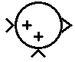

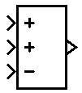

*sum* block you can change the shape of the block, the number of

inputs, and sign of each input.

Simulink also contains nonlinear functions including trigonometric functions. Keep in mind that the previous *sine wave* block created a new signal , the trigonometric block block calculates the sine of an input signal. By double clicking, you can select any common trigonometric function.

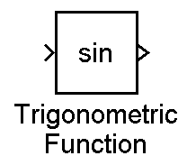

**NOTE: *Simulink and MATLAB always assume RADIANS as the units of all angles for trigonometric functions!***

**Simulink Signals**

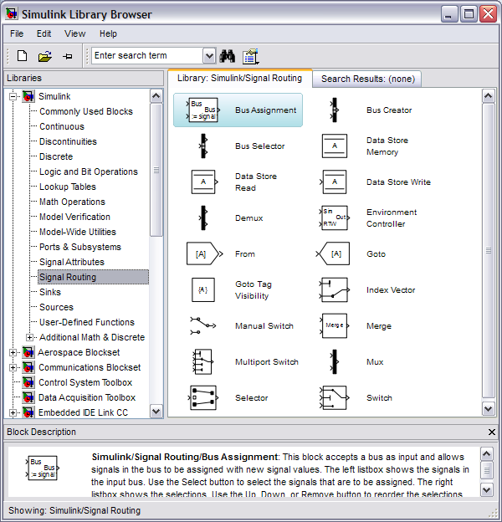

Simulink variables are often called signals. Connecting lines carry these signals from one block to the next block. Sometimes, you may want to label a signal and use it without a connecting line. The *Goto* and *From* blocks perform this function by acting as Simulink signal sinks and sources with invisible connecting lines.

**Saving and Displaying Simulink Variables**

To display or save a signal, connect the signal to a *signal sink*. The Simulink Library Browser*Simulink / Sinks* branch contains the *to workspace* function which looks like the block to the right: This block transfers the input signal from Simulink to the MATLAB workspace. Double click on the *to workspace* block to change the MATLAB variable name.

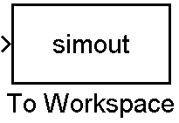

***IMPORTANT:*** Be sure to change the *save format* field to *matrix* so that the MATLAB variable is stored as a column vector. You will need to make these changes every time you use a *to workspace* block.

**NOTE:** Simulink will automatically save the simulation time as a MATLAB column vector called *tout*. You can explicitly generate a time vector using a C*lock* block and a *To Workspace* block with the name *t*.

Use the *Scope* block to display signals directly in Simulink. The S*cope* block is useful for testing your simulation. You can open your *Scope* by double clicking. To change Scope properties, click on the *Scope* properties button just left of the print button. Right click on the *Scope* axis to adjust the axis scaling.

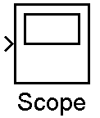

For your lab reports, always use the *To Workspace* function to transfer your data to MATLAB and plot your data using the MATLAB *plot* command. Keep in mind that all lab report plots must contain your name, a descriptive plot title, and axis labels.

**Building a Simulink Model to Solve a Differential Equation**

We now have all the components necessary to create the following Simulink model. The following example constructs a Simulink solution to the differential equation:



If we solve for the highest derivative, we obtain:



In this equation, the right hand side gives the integrand,, in terms of the input, , and the output, A Simulink model to calculate the step response follows:

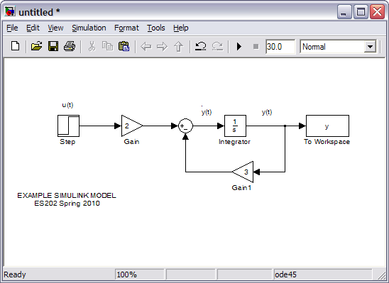

To construct this model:

1. Create a new model
2. Drag the *Step, Gain, Sum, Integrator*, and *To Workspace* blocks from the Simulink Library Browser
3. Copy and paste the *Gain* block to create the second *Gain* block
4. Click right on the second *Gain* block, click *Format* and then click *Flip Block* to make the second *Gain* block point toward the left.
5. Connect the blocks by depressing the left mouse button on an output “nub” of the source block and dragging the mouse to the input “nub” of the destination block
6. Create the feedback loop by depressing the right mouse button over the line between the *Integrator* and to *To Workspace* blocks and dragging a branch line to the second *gain* block. OR, you can left0click on the input of the second gain and drag back to a point on the output line from the *Integrator* and release… the results are the same.
7. Configure each block by double clicking and:
   1. Changing the *Step* start time to 0
   2. Changing the first *Gain* block gain to 2
   3. Changing the second *Gain* block gain to 3
   4. Changing the *To Workspace* ‘Format’ to ‘array’
   5. Changing the *To Workspace* ‘Variable name’ to ‘y’.
   6. Changing the *Sum* block ‘List of signs’ to |+-.
8. Configure the simulation by clicking on the *Simulation* menu bar item (in the model window) and selecting *Parameters.* 
   1. In the default *Solver* context, change the simulation ‘Stop time’ to 3 seconds (you can also do this on the menu just to the right of the play and stop icons).
   2. Go to *Diagnostics* and change ‘Automatic Solver Parameter Selection’ from *Warning* to *none*.
   3. Go to Data Import/Export and unclick the ‘Limit data points to last’ checkbox.
9. Add labels where appropriate by double-clicking on the background of the model and typing the label or other text.
10. Save your model by clicking on the save icon and giving it an appropriate name.Run your model by clicking on the run icon: 

**Plotting Your Simulink Results**

After successfully running your simulation, you can access and plot the results in MATLAB. The following MATLAB commands plot the system step response:

» whos

Name Size Bytes Class

y 62x1 496 double array

tout 62x1 496 double array

Grand total is 124 elements using 992 bytes

» plot(tout,y)

» grid

» title('Prof. Zivi - 1^{st} Order Step Response')

» xlabel('Time, sec.'), ylabel('Amplitude')



**Troubleshooting:**

* If Simulink reported an error when you ran the simulation, check to see that all of your blocks are connected and that the parameters are set as discussed above.
* If your system response began rising at 1 second instead of 0 as shown above, go back and change the ‘Step time’ to 0 in your *Step* block parameters.
* If your system goes unstable (the *y* variable increases to a very large number), you need to check the signs on the summation block. If the sign on the feedback is incorrect, the system will go unstable. This is a concept that you will see very clearly in future systems engineering classes.
* If MATLAB gave you an error when you plotted the results:
  + Make sure that you are using *tout* and the variable name you entered in the *To Workspace* block.
  + Make sure that the Format for the *To Workspace* block is ‘array’ and not ‘Structure’.

**Adding a Simulink Scope Display**

It is often convenient to be able to visualize the simulation data before returning to MATLAB for plotting. The Simulink *Scope* signal sink performs this function. To add a *Scope*:

1. Drag a *Scope* from the *Simulink / Sinks* library branch
2. Connect the *Scope* to the output signal by right-clicking on the existing line (y(t)) and dragging a connection to the *Scope* input “nub”
3. Double click on the *Scope* block to open the *Scope*
4. Run your model by clicking on the run icon: 
5. Right-click on the plot and select *autoscale* (or click on the binocular icon).

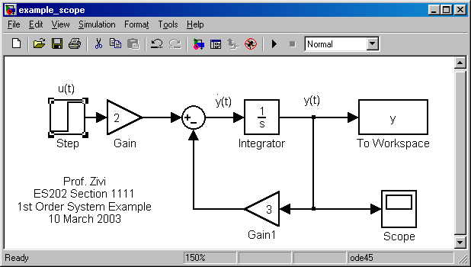

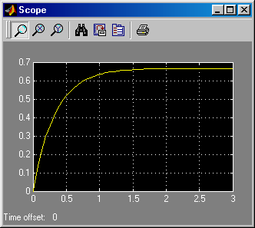

**Selecting and Moving Blocks**

The simplest way to select a block is to point at it with the mouse and click the left mouse button. You can select multiple blocks by holding down the *shift* key. You can select a rectangular group of blocks by beginning at an empty space and diagonally dragging across a group of blocks. As shown on the *Step* block in the previous figure, selected blocks have small black handles that appear in the corners. To un-select an object, either select something else or point the mouse at nearby empty space and click the left mouse button.

To move a block or group of blocks, depress the left mouse button and drag the block(s) to a new location.

Adding Annotation

Each block name in a diagram must be unique and must contain at least one character. Because names must be unique, producing a second copy of a block causes an instantiation number to be added to the block name. To change a block name, left click on the name and edit.

To add annotation text, double-click on any empty space. It is good practice to place the signal name near each connecting line. Always add your name, class, and section number to your Simulink diagram. Simulink Lab reports must always include a properly annotated Simulink diagram.